**Autopipeline Manual**

API for Batch Processing Dream3d

**Tyler Weihing (SOCHE), Dr. Joseph C. Tucker (UES)**

**November 21, 2014**

Contents

Introduction 3

Getting Started with Autopipline 3

Download 3

Installation 3

Setup 3

Support 4

Autopipeline Tutorials 4

# Introduction

The autopipeline GUI is an interactive program that allows for the batch processing of Dream3d workflows. Currently, Dream3d does not support iterative processing of pipelines, and therefore the user incurs a large time burden when required to run multiple instances of Dream3d. With autopipeline, the user is able to load in a predetermined pipeline text file, specify the properties to iterate, and batch process the group from one interface.

1. Software Requirements
   1. MATLAB
   2. Dream3d
   3. Paraview (for visualization)
   4. Windows
2. Terms of Use
   1. Please refer to Dream3d License [here](http://dream3d.bluequartz.net/?page_id=448).

# Getting Started with Autopipline

The following sections provide the necessary information for new users to obtain and set up

Autopipeline. This involves downloading the folder from the Dream3d website. Developers or those interested in maintaining an up-to-date version of the code should consider checking out a copy from the git repository.

## Download

The Autopipeline package is available at this website. The autopipline version will match the release version on the same website.

## Installation

Once the autopipeline folder is finished downloading, unzip and move the folder to the location of your choice. The authors recommend the default MATLAB folder, which is usually found in the ‘Documents‘ directory.

## Setup

In order to run the autopipeline GUI, first open MATLAB. From the command window, navigate to the directory where the GUI folder is located. Right-click on the autopipeline folder, mouse-over “Add to Path,” and click the “Select Folders and Subfolders” option. This is shown in Figure 1. You are now ready to start using autopipeline!

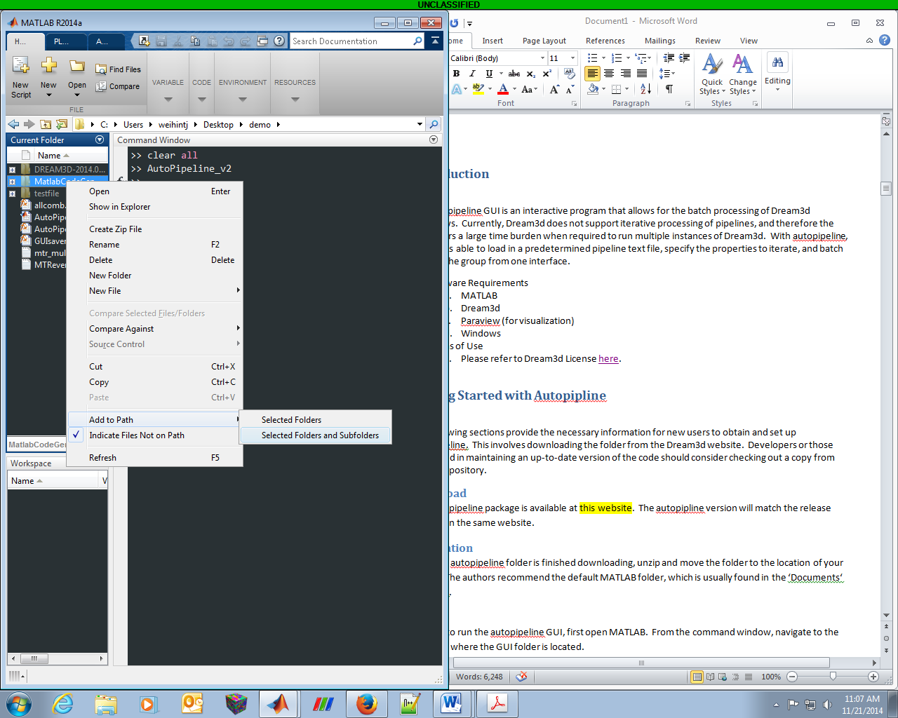

Figure .

## Support

Autopipeline is not commercial code and there are no guarantees or claims, stated or implied,

pertaining to its fitness for any purpose. For all questions and inquiries, please contact the Dream3d developers.

# Autopipeline Tutorials

The following sections present a few short tutorials on running autopipeline. It is important that the user have a fully functioning Dream3d pipeline before attempting to use this GUI. The user will benefit from having [Paraview](http://www.paraview.org/) installed on their computer for verification of the process. Refer to the Paraview website and documentation for any questions regarding this program.